# SPRINT 3

|  |  |
| --- | --- |
| Date | 14 November 2022 |
| Team ID | PNT2022TMID48844 |
| Project Name | Smart Farmer-IoT Enabled smartFarming Application |

**Creating Mobile app using MIT app Inventor SMART FARMER APPLICATION**

App Inventor and IOT can work together to help us understand, and change, our everyday lives.

# Blocks

**QR CODE FOR APK DOWNLOAD:**

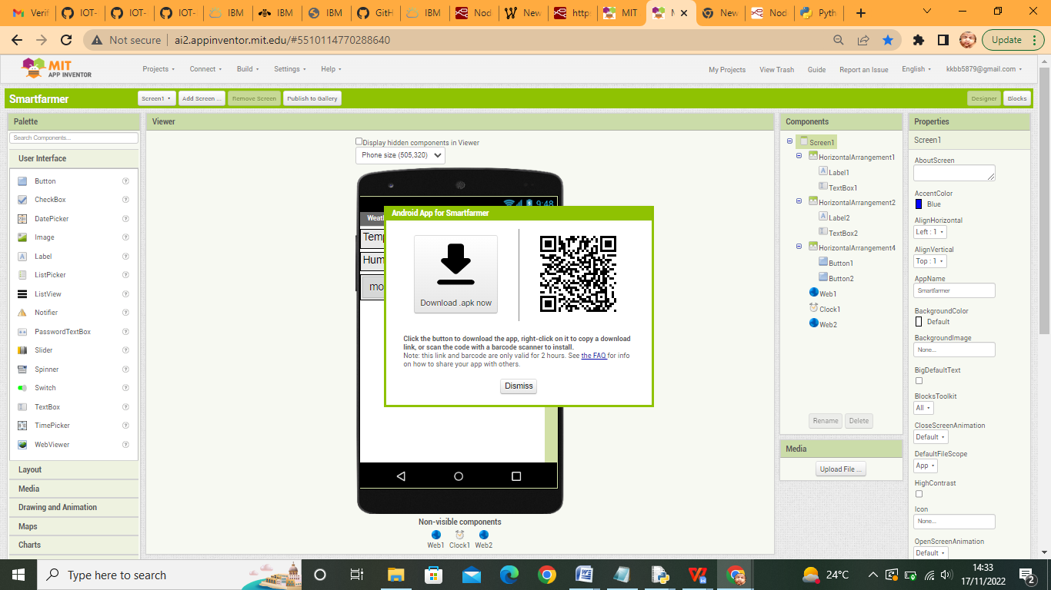

DESIGNER AND BLOCK SCREEN :

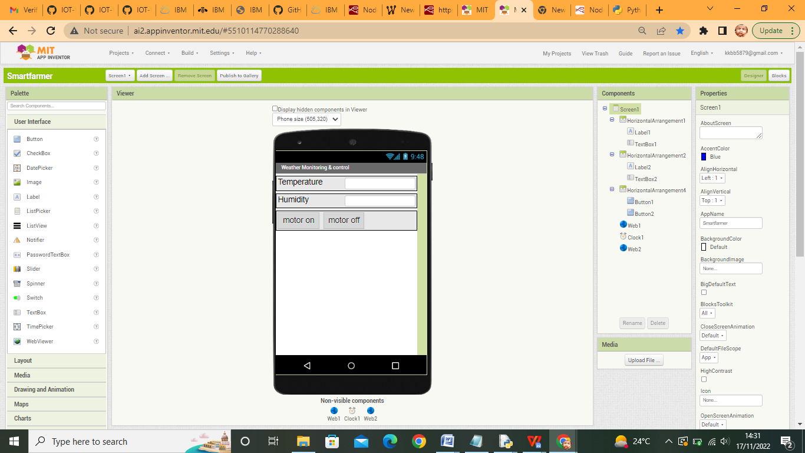

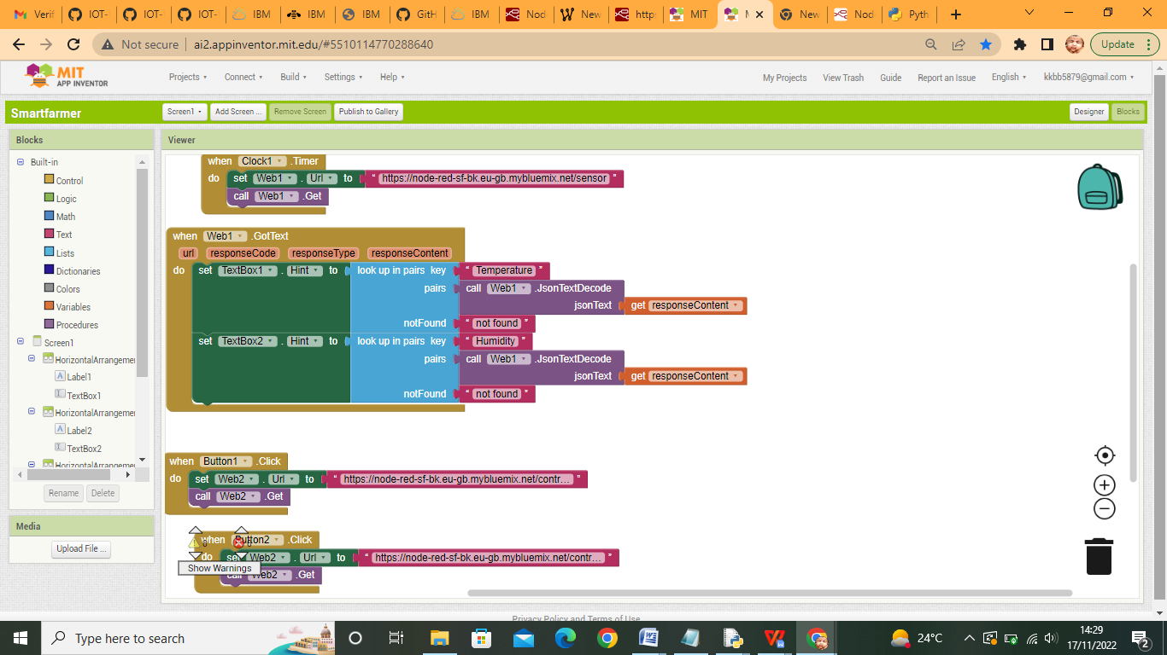

**OUTPUT SCREEN:**

